Library Name: | cgm
Cell Name: | MUX2XI
Function/Truth Table:
S A B |  | Y
0 0 0 |  | 0
0 0 1 |  | 0
0 1 0 |  | 1
0 1 1 |  | 1
1 0 0 |  | 0
1 0 1 |  | 1
1 1 0 |  | 0
1 1 1 |  | 1
Propagation Delay (path based):
Transition |  | Delay (s)
A → Y ↑ (T_PLH) |  | 934.3p
A → Y ↓ (T_PHL) |  | 1.156n
B → Y ↑ (T_PLH) |  | 936.5n
B → Y ↓ (T_PHL) |  | 1.157n
S → Y ↑ (T_PLH) |  | 963.1p
S → Y ↓ (T_PHL) |  | 1.191n
Output Rise Time (path based):
Transition |  | Rise Time (s)
A → Y ↑ |  | 2.207n
B → Y ↑ |  | 2.2n
S → Y ↑ |  | 2.2n
Output Fall Time (path based):
Transition |  | Fall Time (s)
A → Y ↓ |  | 2.978n
B → Y ↓ |  | 2.962n
S → Y ↓ |  | 2.979n
Layout Height:
Layout Width:
Layout Area:
Symbol with Port Names:

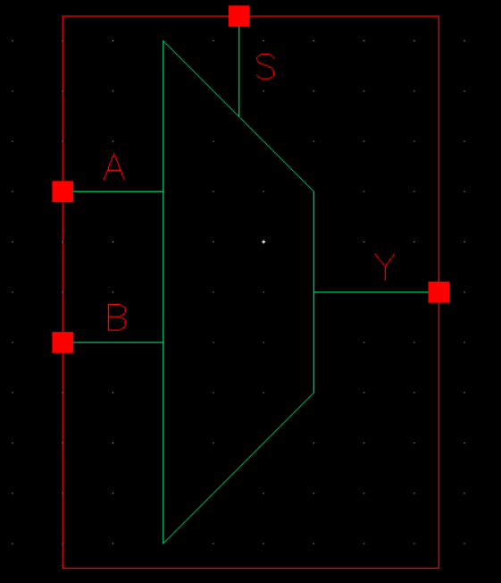
Schematic:

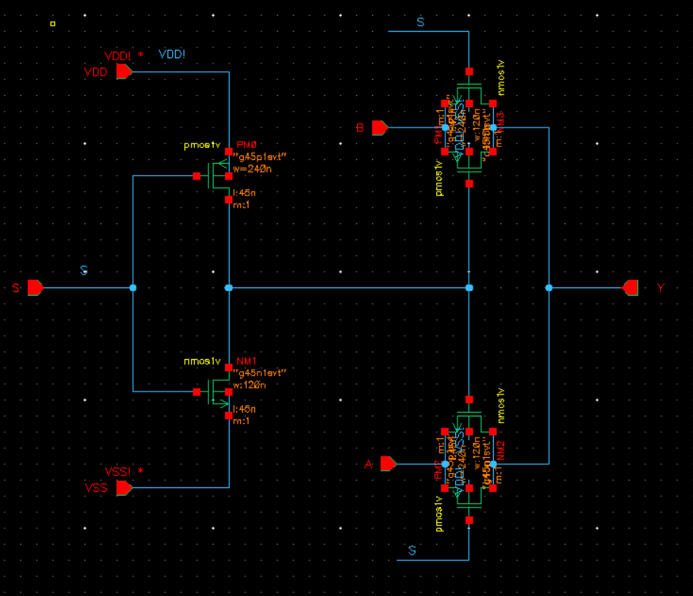
Layout:
Functional Simulation Waveforms

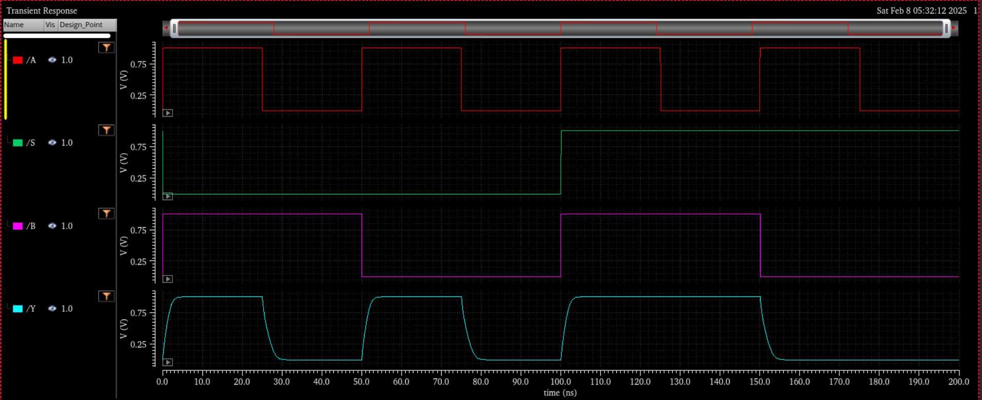

Comments/Notes:

The MUX2XI gate was tested and verified. Y follows A when S = 0 and B when S = 1, confirming correct functionality. Propagation delays and rise/fall times were within expected ranges, with fall transitions being slightly longer. All functional and timing tests passed, ensuring reliable operation.

